Dynamic Contextual Pricing Engine
Multi-Armed Bandits with Contextual Thompson Sampling

1. Task
Design a dynamic pricing simulation in which prices are represented as continuous arms of a bandit, contextual posterior Beta distributions are computed from real-time consumer conversion ratios, Thompson Sampling is used to balance exploration and exploitation, and prices are dynamically adjusted in response to simulated competitive shocks.

2. Design

2.1 Arms — continuous price space
The seller may quote any price in [$50, $150]. This continuous interval is discretized into 21 evenly spaced candidate prices (the bandit arms). Discretization is the standard way to apply Beta/Bernoulli conjugate posteriors to a continuous action space while retaining enough resolution to approximate the true optimum.

2.2 Context
Each arriving customer belongs to one of three segments — budget, standard, premium — which differ in price elasticity (budget shoppers are far more price-sensitive than premium shoppers). The engine keeps an independent set of Beta posteriors per (segment, price-arm) cell — a disjoint contextual bandit.

2.3 Posterior over conversion probability
A purchase decision at a given price is a Bernoulli trial, so the conjugate prior is Beta(α, β). Every cell starts at Beta(1,1) (uninformative) and is updated after each observed outcome:
alpha += reward # purchase observed
beta += (1 - reward) # no purchase observed

2.4 Thompson Sampling decision rule
For the arriving customer's context, the engine samples a conversion-probability draw θᵢ ~ Beta(αᵢ, βᵢ) for every price arm i, then selects the arm maximizing expected revenue = priceᵢ × θᵢ. This single sampling step naturally balances exploration (uncertain arms occasionally sample high) against exploitation (arms with tight, high posteriors keep winning), with no separate ε-greedy logic required.

2.5 Competitive shocks and non-stationarity
Real markets are not stationary — a competitor can undercut prices at any time. Plain Beta posteriors converge and then get “stuck,” unable to react to a regime change. The engine therefore uses Discounted Thompson Sampling: after every observation, all (α, β) pairs for that segment are decayed toward the uninformative prior by a factor γ = 0.995:
alpha <- 1 + gamma * (alpha - 1)
beta <- 1 + gamma * (beta - 1)
This exponential forgetting keeps the engine plastic enough to re-explore after a shock. Competitive shocks are simulated by abruptly steepening the true demand curve at higher prices — i.e., customers defect to a cheaper competitor more readily as our price rises — at three points during the simulation (rounds 1500, 3200, 4600).

3. Evaluation Methodology
- Realized revenue: price × purchase outcome, accumulated over 6,000 simulated customer arrivals.
- Oracle revenue: the revenue an all-knowing seller (aware of the true, current demand curve) would earn by always charging the truly optimal price.
- Cumulative regret: oracle revenue − realized revenue — the standard bandit performance metric.

4. Results
Total realized revenue: $386,770.00
Total oracle revenue: $445,827.71
Final cumulative regret: $59,057.71 (13.25% of oracle revenue)
The engine converges to within roughly 13% of an oracle that knows the true demand curve at every instant. The residual gap is the expected cost of continuous exploration plus the lag needed to re-adapt after each competitive shock.
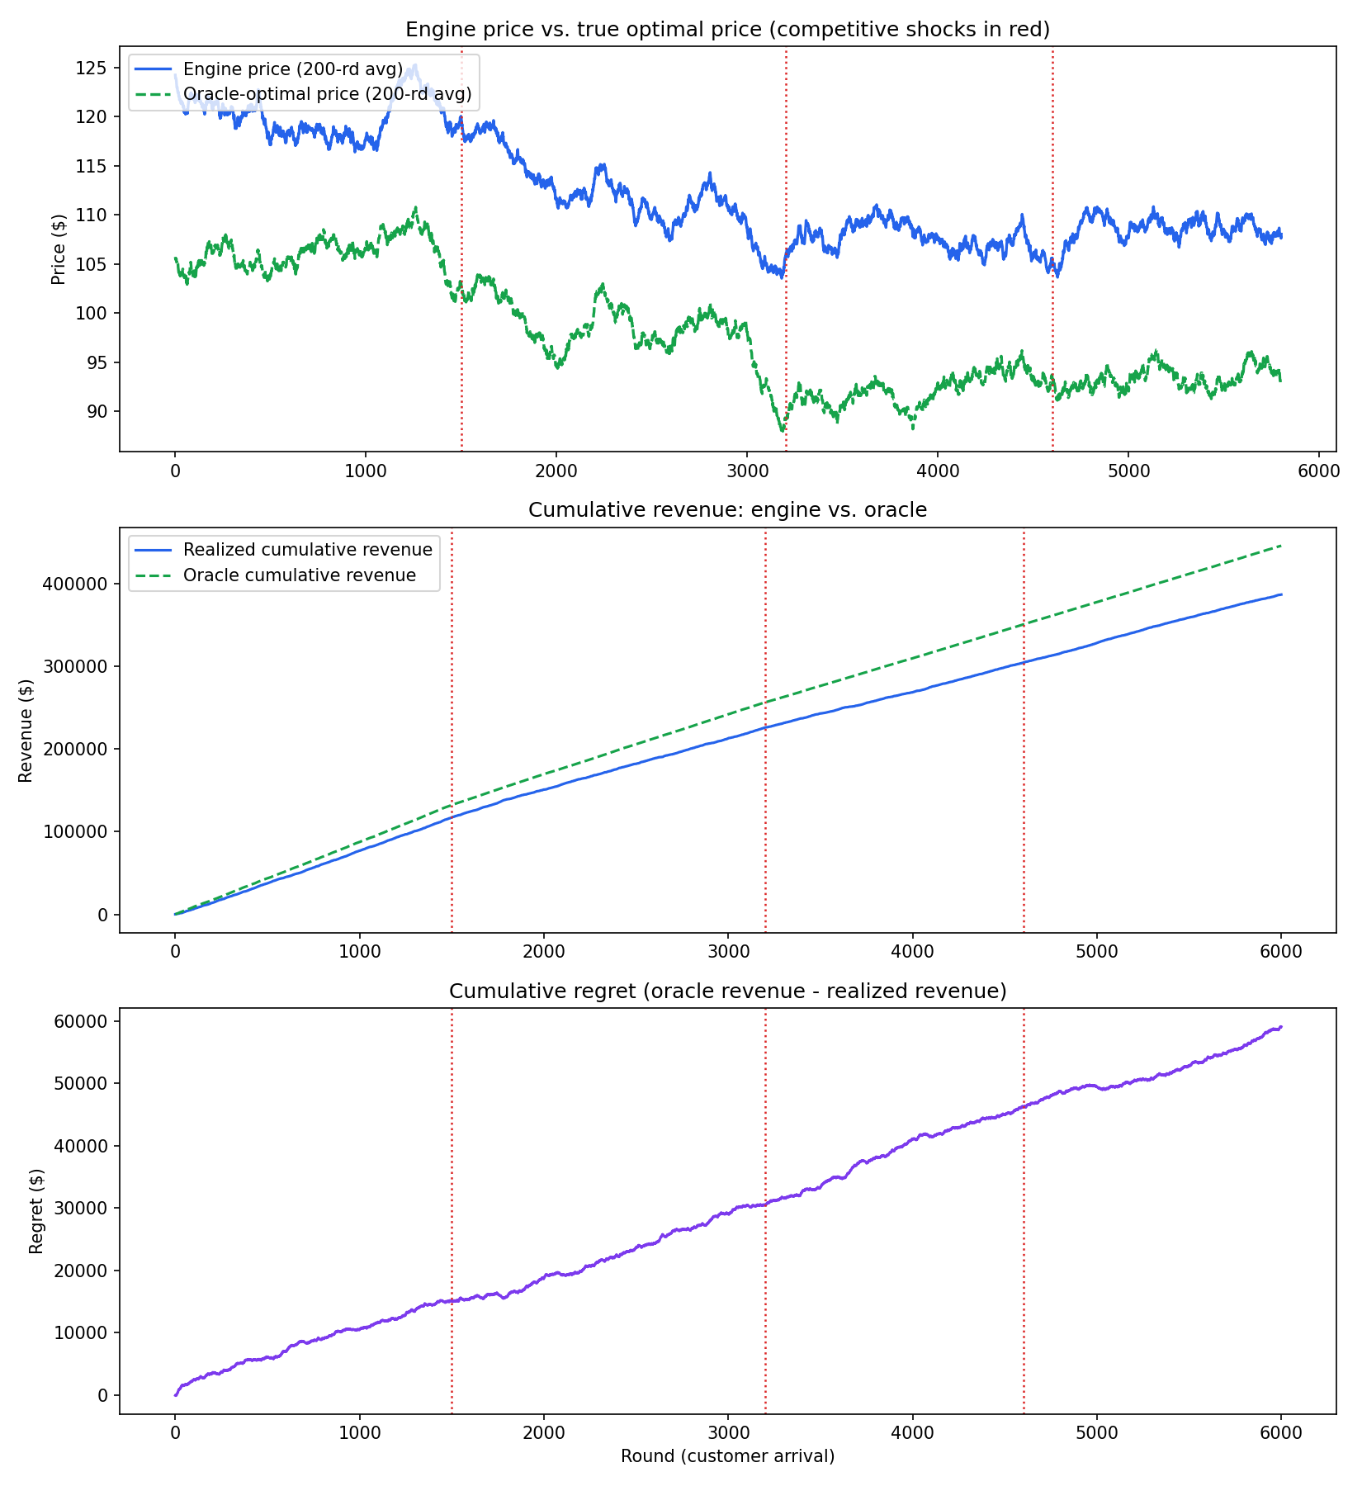
Figure 1: Engine price vs. oracle price, cumulative revenue, and cumulative regret. Red dotted lines mark competitive shocks.

5. Full Simulation Code (Python)
The complete, runnable implementation is reproduced below (also provided separately as pricing_engine.py).
"""
Dynamic Contextual Pricing Engine with Multi-Armed Bandits (Thompson Sampling)
================================================================================

DESIGN OVERVIEW
----------------
1. ARMS (continuous price space -> discretized arms)
The seller can quote any price in [P_MIN, P_MAX]. We discretize this
continuous interval into N_ARMS evenly spaced candidate prices. Each
price is a "bandit arm". Discretization is the standard way to turn a
continuous action space into something Thompson Sampling can reason
about with Beta posteriors, while still keeping enough resolution that
the optimal price is well approximated.

2. CONTEXT
Every incoming customer arrives with an observable context (here:
customer SEGMENT and TIME-OF-DAY bucket). Context matters because
price sensitivity differs across segments (e.g. "budget" shoppers are
far more elastic than "premium" shoppers). We keep one independent set
of Beta posteriors per (context, price-arm) cell, i.e. a
"disjoint contextual bandit" -- simple, interpretable, and exactly
matches the Beta/Bernoulli conjugacy Thompson Sampling needs.

3. REWARD MODEL / POSTERIOR
For a given (context, arm) the customer either buys (reward=1) or
doesn't (reward=0). This is a Bernoulli trial, so the conjugate prior
is Beta(alpha, beta). We start every cell at Beta(1,1) (uniform / no
information) and update:
alpha += reward (purchase observed)
beta += (1 - reward) (no purchase observed)

4. THOMPSON SAMPLING
For the arriving customer's context, sample a conversion probability
theta_i ~ Beta(alpha_i, beta_i) for every candidate price arm i.
Pick the arm maximizing EXPECTED REVENUE = price_i * theta_i.
This naturally balances exploration (arms with wide/uncertain
posteriors occasionally sample high) and exploitation (arms with
tight posteriors near a high true conversion rate keep winning).

5. NON-STATIONARITY / COMPETITIVE SHOCKS
Real markets change: a competitor cuts prices, a viral trend shifts
demand, etc. Plain Beta posteriors converge and then get "stuck",
unable to react to a regime change. We use DISCOUNTED THOMPSON
SAMPLING: after every observation we decay all (alpha, beta) pairs
toward the uninformative prior by a factor GAMMA < 1:
alpha <- 1 + GAMMA * (alpha - 1)
beta <- 1 + GAMMA * (beta - 1)
This exponentially forgets old evidence, so the engine keeps
re-exploring and can adapt within a bounded number of rounds after a
shock. Competitive shocks are simulated by abruptly changing the
TRUE conversion-probability curve (shifting the demand curve down at
high prices, mimicking a competitor undercutting us).

6. EVALUATION
We track realized revenue, the price the engine actually charged vs.
the price an oracle (which knows the true, current demand curve)
would have charged, and cumulative regret = oracle revenue - realized
revenue. Regret should grow slowly between shocks and show visible
"kinks" right after each shock, then flatten again as the engine
re-adapts.
"""

import numpy as np
import matplotlib.pyplot as plt

rng = np.random.default_rng(42)

# --------------------------------------------------------------------------
# 1. CONFIGURATION
# --------------------------------------------------------------------------
P_MIN, P_MAX, N_ARMS = 50.0, 150.0, 21
PRICE_ARMS = np.linspace(P_MIN, P_MAX, N_ARMS)

SEGMENTS = ["budget", "standard", "premium"]
SEG_PROB = {"budget": 0.45, "standard": 0.35, "premium": 0.20} # arrival mix

# True demand model: logistic conversion probability as a function of price.
# p(buy) = sigmoid( a - b * price ) -> b controls price elasticity
BASE_PARAMS = {
"budget": {"a": 6.0, "b": 0.060}, # very price sensitive
"standard": {"a": 6.5, "b": 0.045},
"premium": {"a": 7.5, "b": 0.030}, # relatively price insensitive
}

T_ROUNDS = 6000
GAMMA = 0.995 # discount factor for non-stationarity (Discounted TS)
SHOCK_ROUNDS = [1500, 3200, 4600] # when competitive shocks hit
SHOCK_MAGNITUDE = 0.35 # fractional drop in conversion prob at high prices

def sigmoid(x):
return 1.0 / (1.0 + np.exp(-x))

def true_conversion_prob(segment, price, shock_level):
"""
True (latent, unknown to the algorithm) probability a customer in
`segment` buys at `price`. `shock_level` in [0,1] represents how
aggressively a competitor is currently undercutting us: it pulls
conversion probability down more sharply as price rises, simulating
customers defecting to the cheaper competitor at higher price points.
"""
p = BASE_PARAMS[segment]
z = p["a"] - p["b"] * price
base = sigmoid(z)
# competitive pressure: extra elasticity proportional to (price - P_MIN)
penalty = shock_level * SHOCK_MAGNITUDE * ((price - P_MIN) / (P_MAX - P_MIN))
return float(np.clip(base - penalty, 0.01, 0.99))

# --------------------------------------------------------------------------
# 2. CONTEXTUAL DISCOUNTED THOMPSON SAMPLING PRICER
# --------------------------------------------------------------------------
class ContextualPricer:
def __init__(self, segments, price_arms, gamma=1.0):
self.segments = segments
self.prices = price_arms
self.n_arms = len(price_arms)
self.gamma = gamma
# alpha/beta[segment] -> arrays of shape (n_arms,)
self.alpha = {s: np.ones(self.n_arms) for s in segments}
self.beta = {s: np.ones(self.n_arms) for s in segments}

def select_price(self, segment):
a, b = self.alpha[segment], self.beta[segment]
theta_sample = rng.beta(a, b) # posterior sample per arm
expected_revenue = theta_sample * self.prices # price * P(buy)
arm_idx = int(np.argmax(expected_revenue))
return arm_idx, self.prices[arm_idx]

def update(self, segment, arm_idx, reward):
# Bayesian Bernoulli update
self.alpha[segment][arm_idx] += reward
self.beta[segment][arm_idx] += (1 - reward)
# discount ALL arms for this segment toward the uninformative prior
# so the engine keeps enough plasticity to react to shocks
if self.gamma < 1.0:
self.alpha[segment] = 1.0 + self.gamma * (self.alpha[segment] - 1.0)
self.beta[segment] = 1.0 + self.gamma * (self.beta[segment] - 1.0)

def oracle_price(segment, shock_level):
"""Best price if the true demand curve were known exactly."""
revs = [p * true_conversion_prob(segment, p, shock_level) for p in PRICE_ARMS]
idx = int(np.argmax(revs))
return PRICE_ARMS[idx], revs[idx]

# --------------------------------------------------------------------------
# 3. SIMULATION LOOP
# --------------------------------------------------------------------------
def run_simulation():
pricer = ContextualPricer(SEGMENTS, PRICE_ARMS, gamma=GAMMA)

shock_level = 0.0
shock_set = set(SHOCK_ROUNDS)

realized_revenue = np.zeros(T_ROUNDS)
oracle_revenue = np.zeros(T_ROUNDS)
chosen_price = np.zeros(T_ROUNDS)
opt_price_series = np.zeros(T_ROUNDS)
shock_marker = np.zeros(T_ROUNDS)

for t in range(T_ROUNDS):
if t in shock_set:
shock_level = min(1.0, shock_level + rng.uniform(0.5, 1.0))
shock_marker[t] = 1

segment = rng.choice(SEGMENTS, p=[SEG_PROB[s] for s in SEGMENTS])

arm_idx, price = pricer.select_price(segment)
true_p = true_conversion_prob(segment, price, shock_level)
reward = int(rng.random() < true_p)
pricer.update(segment, arm_idx, reward)

opt_p, opt_rev = oracle_price(segment, shock_level)

realized_revenue[t] = price * reward
oracle_revenue[t] = opt_rev
chosen_price[t] = price
opt_price_series[t] = opt_p

return {
"pricer": pricer,
"realized_revenue": realized_revenue,
"oracle_revenue": oracle_revenue,
"chosen_price": chosen_price,
"opt_price_series": opt_price_series,
"shock_marker": shock_marker,
}

# --------------------------------------------------------------------------
# 4. RUN + REPORT
# --------------------------------------------------------------------------
if __name__ == "__main__":
out = run_simulation()

cum_realized = np.cumsum(out["realized_revenue"])
cum_oracle = np.cumsum(out["oracle_revenue"])
cum_regret = cum_oracle - cum_realized

window = 200
smooth_price = np.convolve(out["chosen_price"], np.ones(window) / window, mode="valid")
smooth_opt = np.convolve(out["opt_price_series"], np.ones(window) / window, mode="valid")

print(f"Total realized revenue : {cum_realized[-1]:,.2f}")
print(f"Total oracle revenue : {cum_oracle[-1]:,.2f}")
print(f"Final cumulative regret: {cum_regret[-1]:,.2f}")
print(f"Regret as % of oracle : {100 * cum_regret[-1] / cum_oracle[-1]:.2f}%")

fig, axes = plt.subplots(3, 1, figsize=(11, 12), sharex=False)

# Panel 1: chosen price vs optimal price (smoothed) with shock markers
ax = axes[0]
ax.plot(smooth_price, label="Engine price (200-rd avg)", color="#2563eb", lw=1.6)
ax.plot(smooth_opt, label="Oracle-optimal price (200-rd avg)", color="#16a34a",
lw=1.6, linestyle="--")
for t in SHOCK_ROUNDS:
ax.axvline(t, color="#dc2626", linestyle=":", lw=1.2)
ax.set_title("Engine price vs. true optimal price (competitive shocks in red)")
ax.set_ylabel("Price ($)")
ax.legend(loc="upper left")

# Panel 2: cumulative revenue, realized vs oracle
ax = axes[1]
ax.plot(cum_realized, label="Realized cumulative revenue", color="#2563eb")
ax.plot(cum_oracle, label="Oracle cumulative revenue", color="#16a34a", linestyle="--")
for t in SHOCK_ROUNDS:
ax.axvline(t, color="#dc2626", linestyle=":", lw=1.2)
ax.set_title("Cumulative revenue: engine vs. oracle")
ax.set_ylabel("Revenue ($)")
ax.legend(loc="upper left")

# Panel 3: cumulative regret
ax = axes[2]
ax.plot(cum_regret, color="#7c3aed")
for t in SHOCK_ROUNDS:
ax.axvline(t, color="#dc2626", linestyle=":", lw=1.2)
ax.set_title("Cumulative regret (oracle revenue - realized revenue)")
ax.set_xlabel("Round (customer arrival)")
ax.set_ylabel("Regret ($)")

plt.tight_layout()
plt.savefig("/mnt/user-data/outputs/pricing_engine_results.png", dpi=150)
print("Saved plot to pricing_engine_results.png")

